OPEN LAB END SEM

Documentation regarding open lab end sem submission

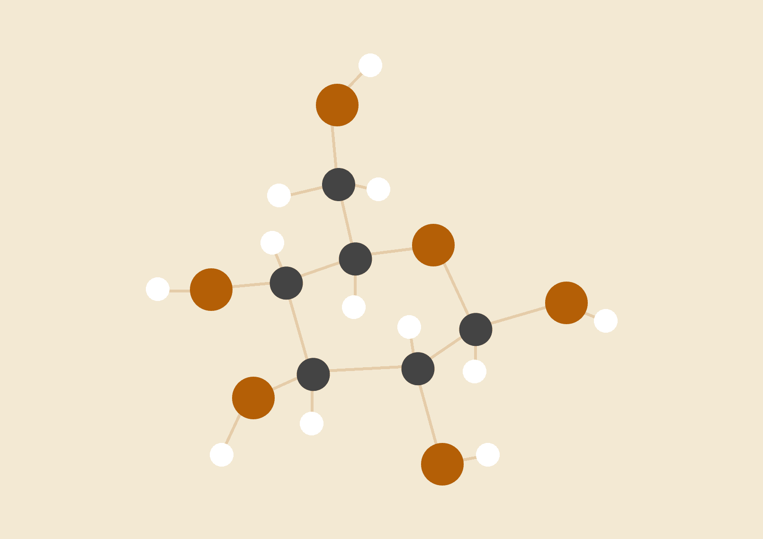

**Mahesh G**

06.05.2020

CB.EN.U4CSE17037

<https://github.com/Mahe-git2hub/openlab-copy2endsem.git>

# INTRODUCTION

This flask project is meant as a news article highlighter. In this project I have tried to extract a news article highlighting the different keywords or terms in the news article. The keyword extraction is done with the help of spacy’s displacy, en_core_web_sm, PhraseMatcher. The displacy function of spacy provides an option of recognising the different parts of speech present with the document. This is used as an input later on for PhraseMatcher.

# Techniques/Concepts/Modules used.

1. Flask - { Flask, render_template, request, flash, redirect, url_for, session, g }
2. SQLALchemy - {declarative_base
3. Spacy
4. NLTK
5. BeautifulSoup
6. Request
7. Wordcloud
8. Pickle

# PROCEDURE

1. Create a virtual environment. ( python -m venv .env )
2. Activate virtual env ( source .env/bin/activate)
3. Run **pip install requirements.txt (Preferably do it in venv)**
4. Run the following commands
   1. pip install -U spacy
   2. pip install -U spacy-lookups-data
   3. python -m spacy download en_core_web_sm
5. Make sure the 4c step is done properly as it may take multiple attempts to successfully finish.
6. Run the python file app.py
7. ( Optional ) If running in colab, install flask-ngrok.
8. You will be directed to the login page.
9. You may login with login cred ( user: “Mahesh” pass: “WE” ) or register yourself
10. Your registration (if registering) will be saved in DB.
11. After you login you will be rendered with an input box to enter the url of the news article. (Though any url will work, preferably go with those news article where you need not login to read the article. )
12. Click submit after entering the full url.
13. Once you click submit go to your python console and enter the number of sentences to consider for parallel computation.
    1. This number would be the number of words that would appear in the dependency graph
    2. Giving very high numbers( like 23 and above ) would either result in OutofMemory exception or a very slow execution.
    3. Ideally sent nums should be between 10 - 18
    4. A svg file is created which has your dependency graph.
14. The page redirects itself to NER route where we can see the major keywords that determine the article contents.
15. WordCloud is given in another python file. It generally takes about 20 mins to run wordcloud. An image of the result of the previous run is attached. At each run a new image is created. Please delete the old image before running the function.
16. You may now terminate the app.

# Note:

The model is not 100% accurate. It’s accuracy ranges from 89% - 91.21%. There is a lot of mislabelling in the states of India. This is because all the news article training was done during COVID-19 period. Because in NewsPapers the name of cities is used as a collective noun for people of a city, the models tend to predict them as a person.

# Screenshots

1. Login Page
2. Register page
3. Login page with default login
4. The News site url page.
5. The News article Url is entered
6. The Favicon is shown in running state.
7. Entering the number of input sentences as input for dependency graph ( if value is not provided the app will keep on waiting)
8. We can that the display.html file is rewritten every time we run the app. Shown here is an excerpt of the page.
9. The Dependency graph and wordcloud images are shown.
10. Error page.

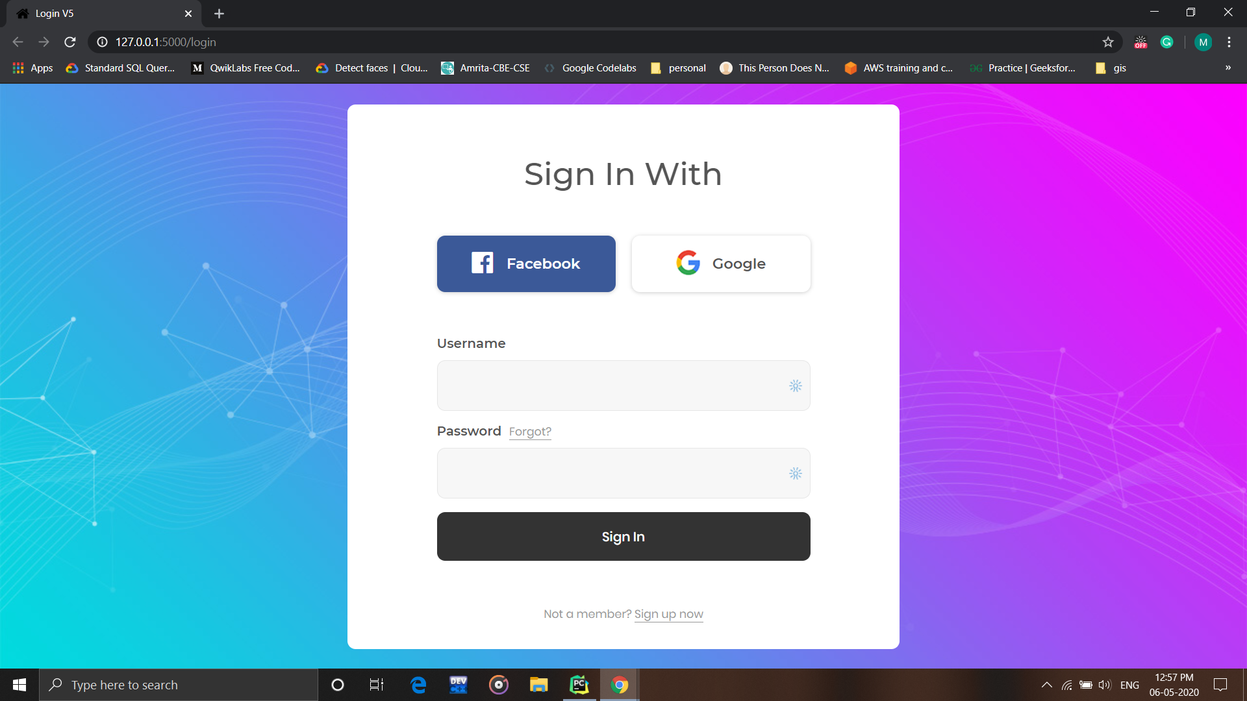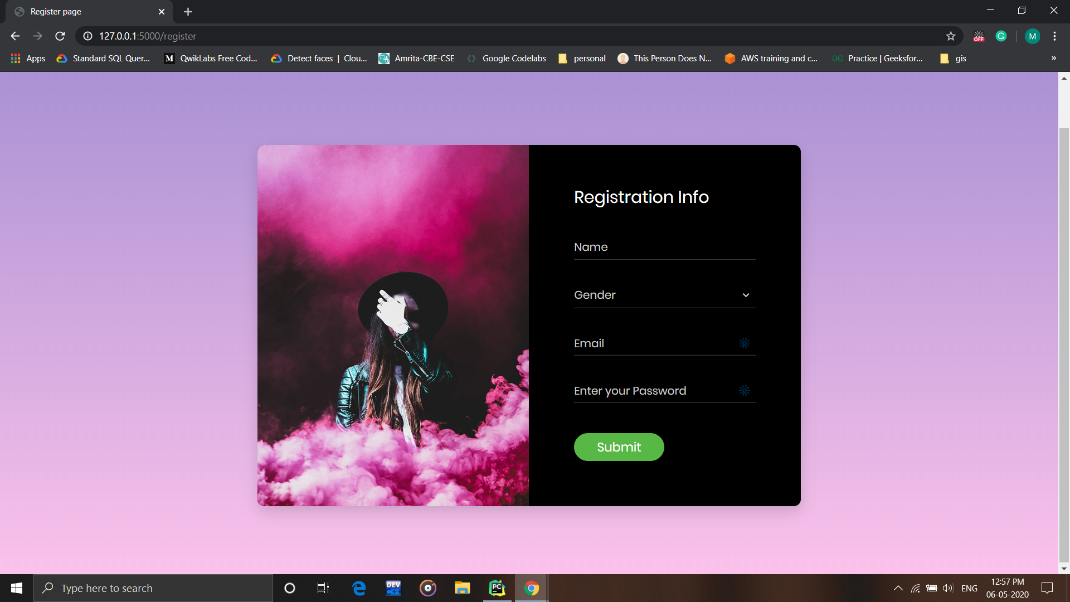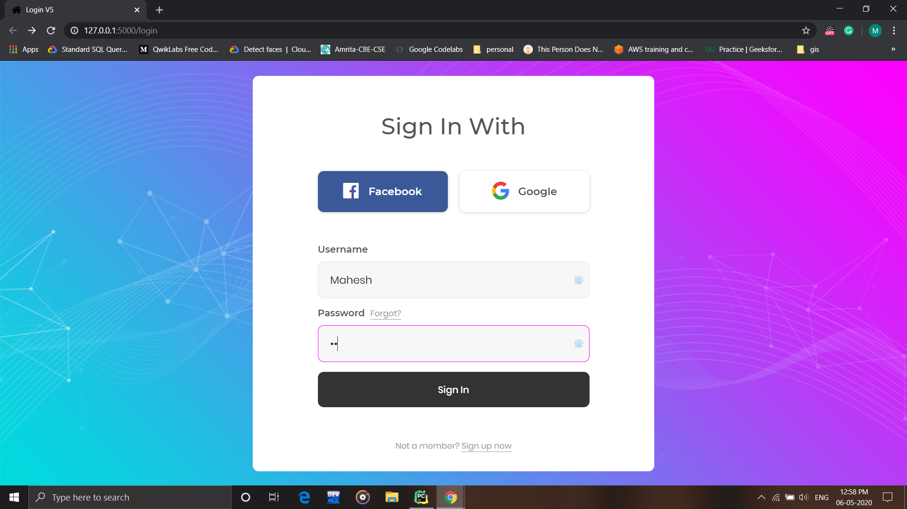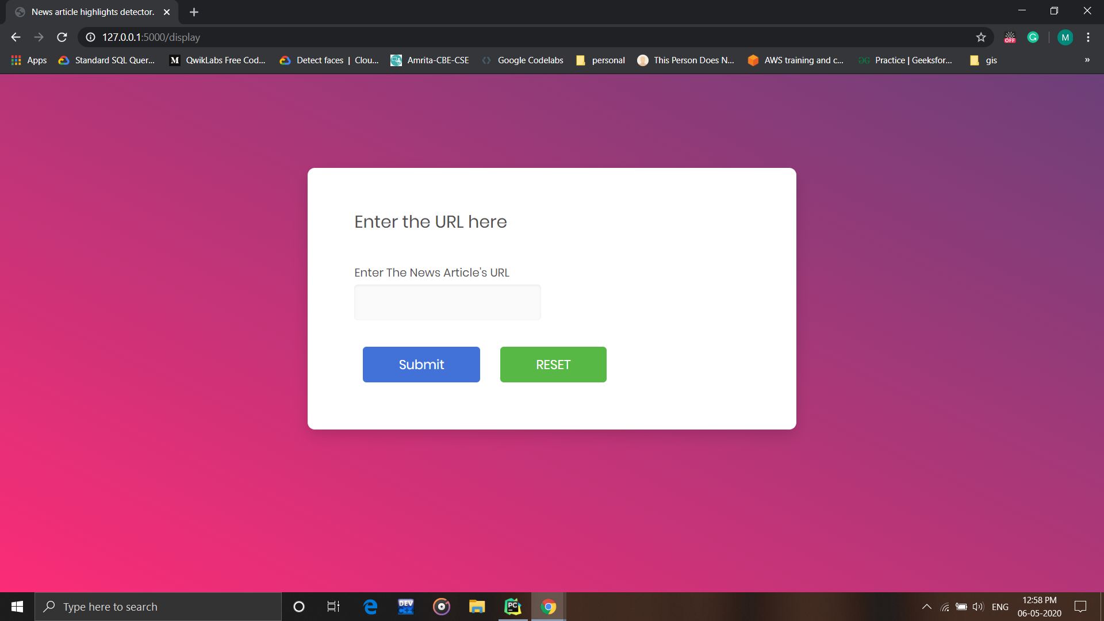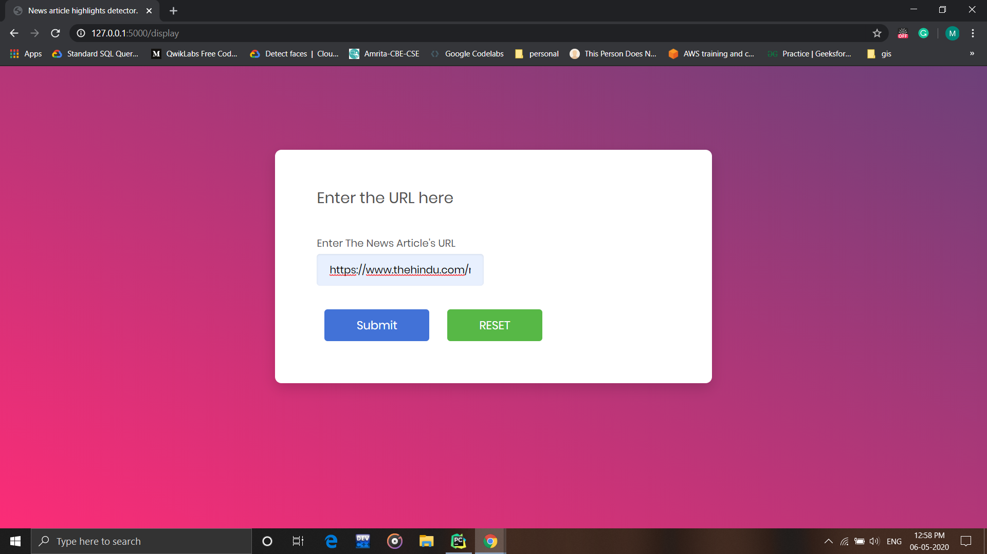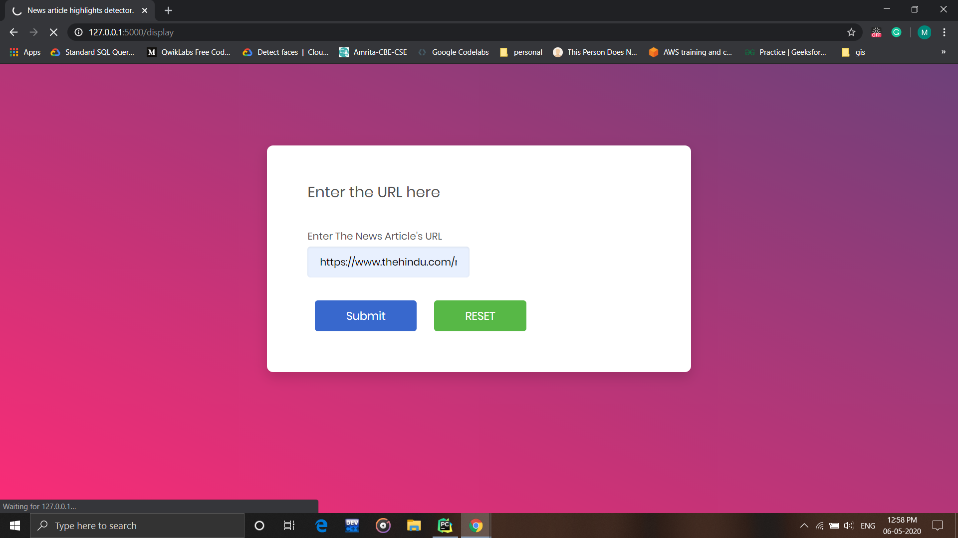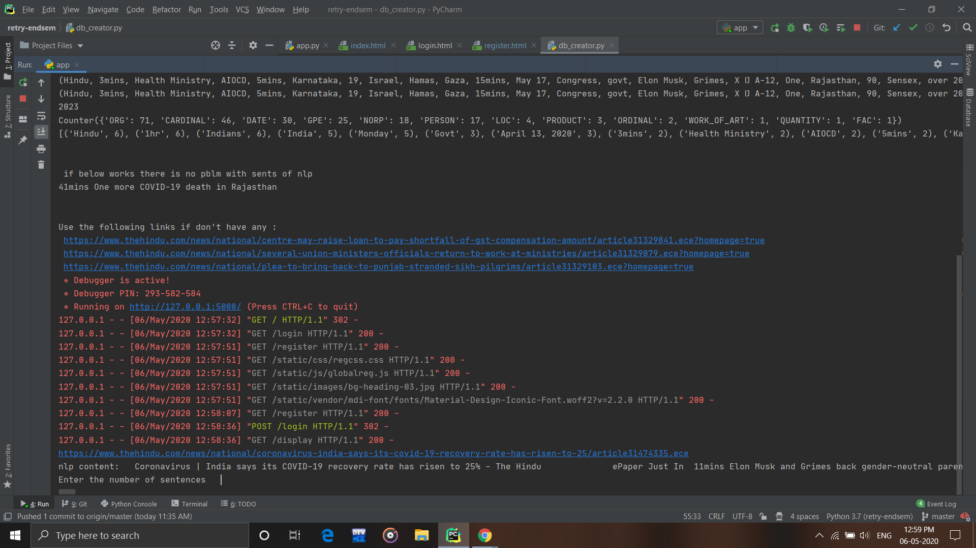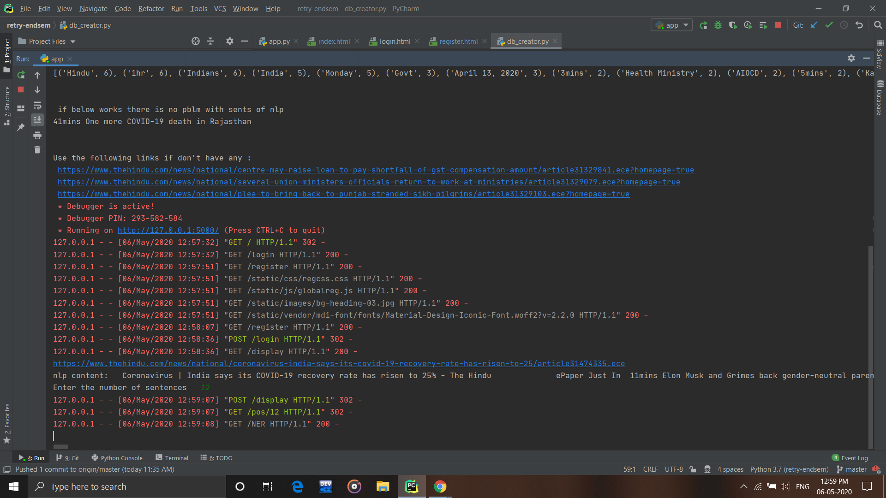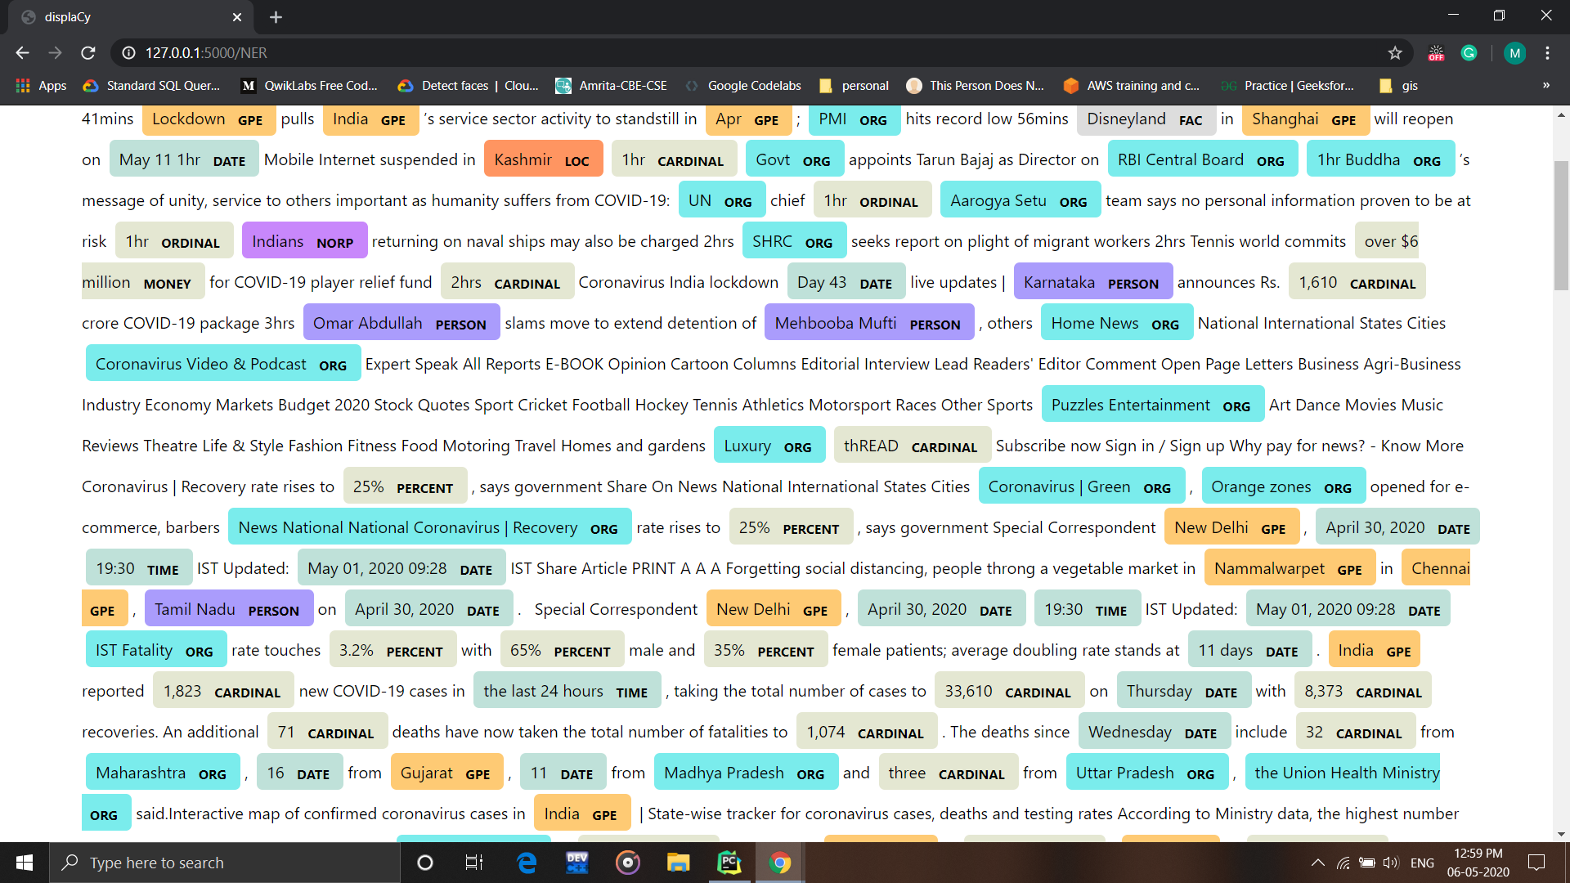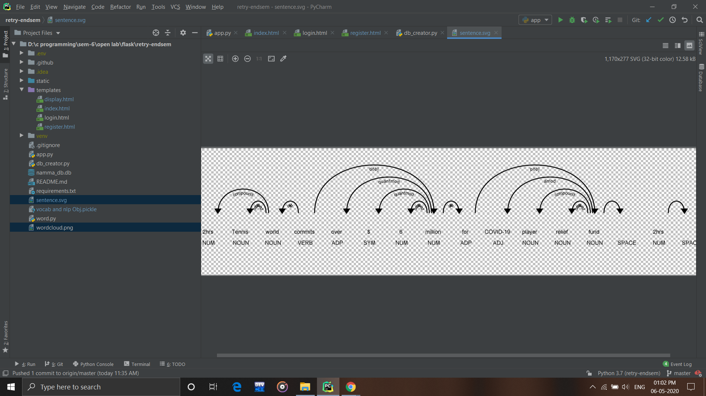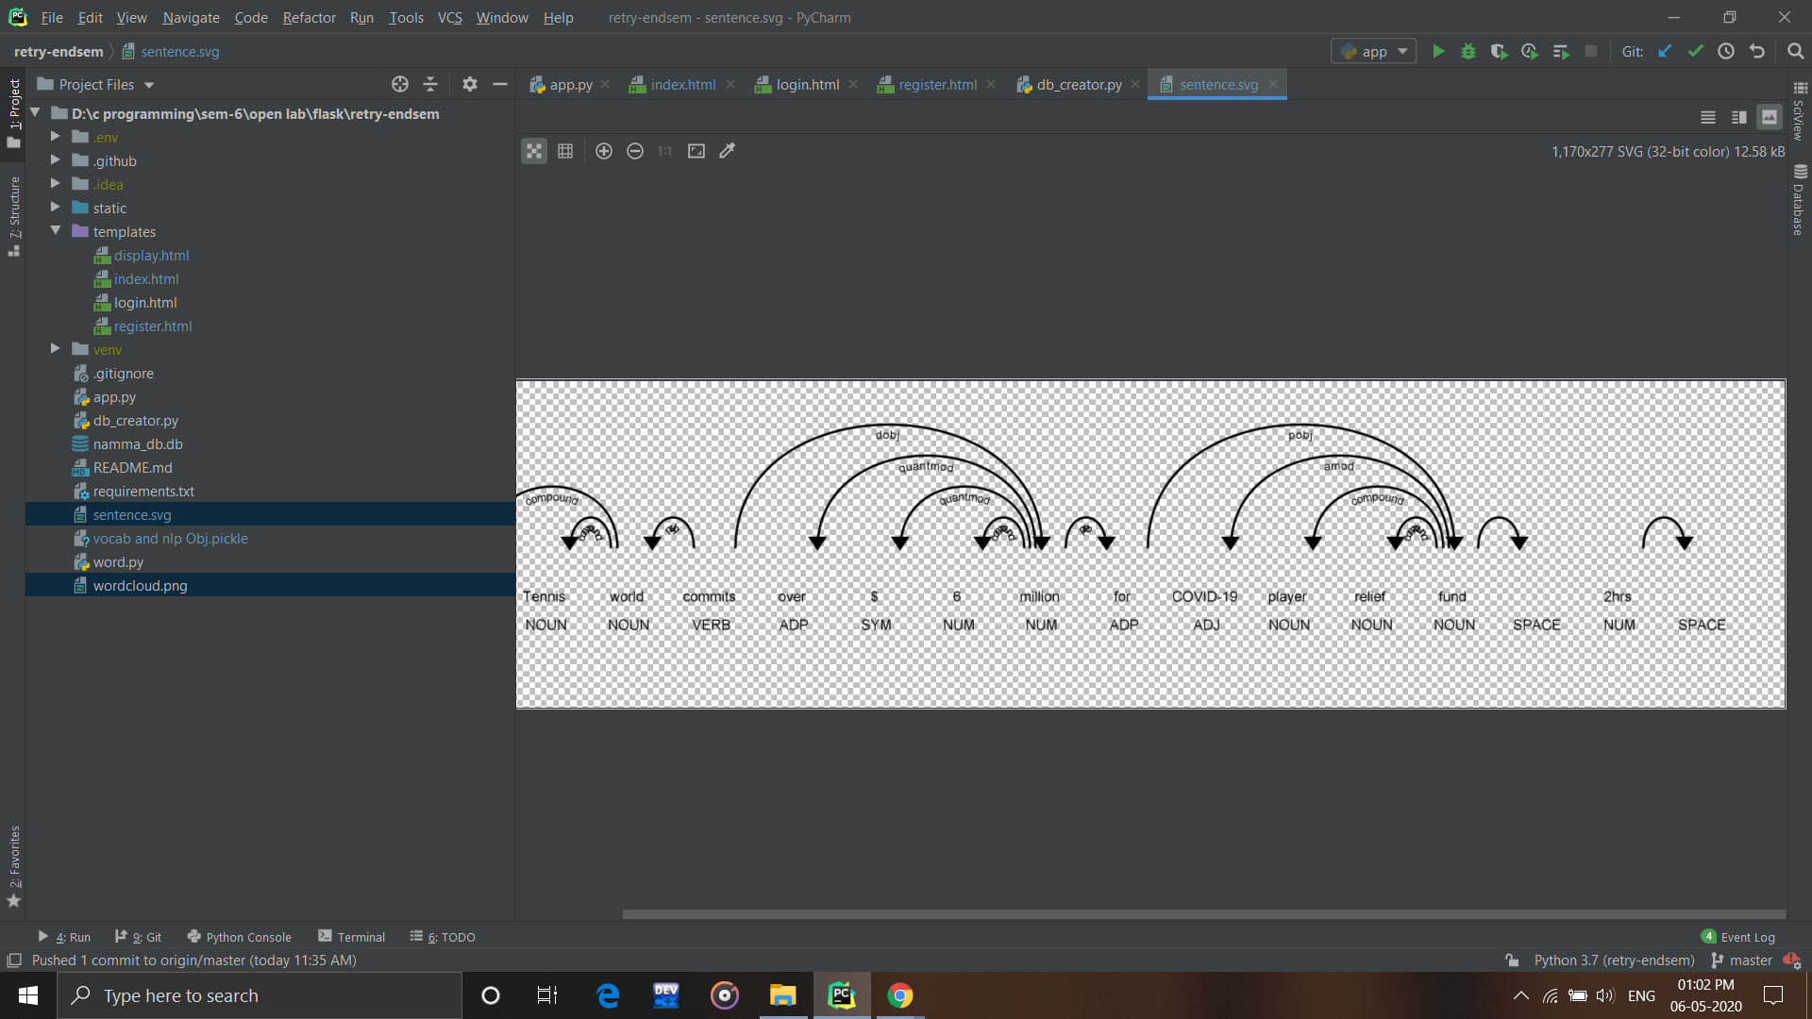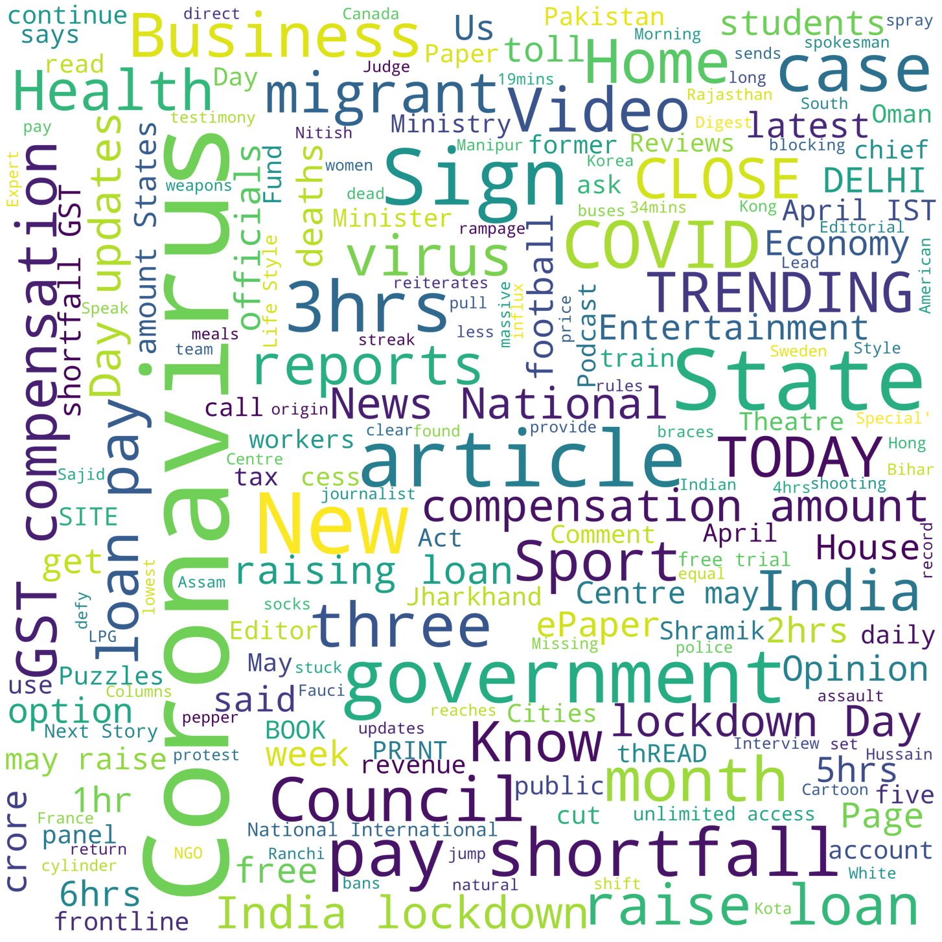

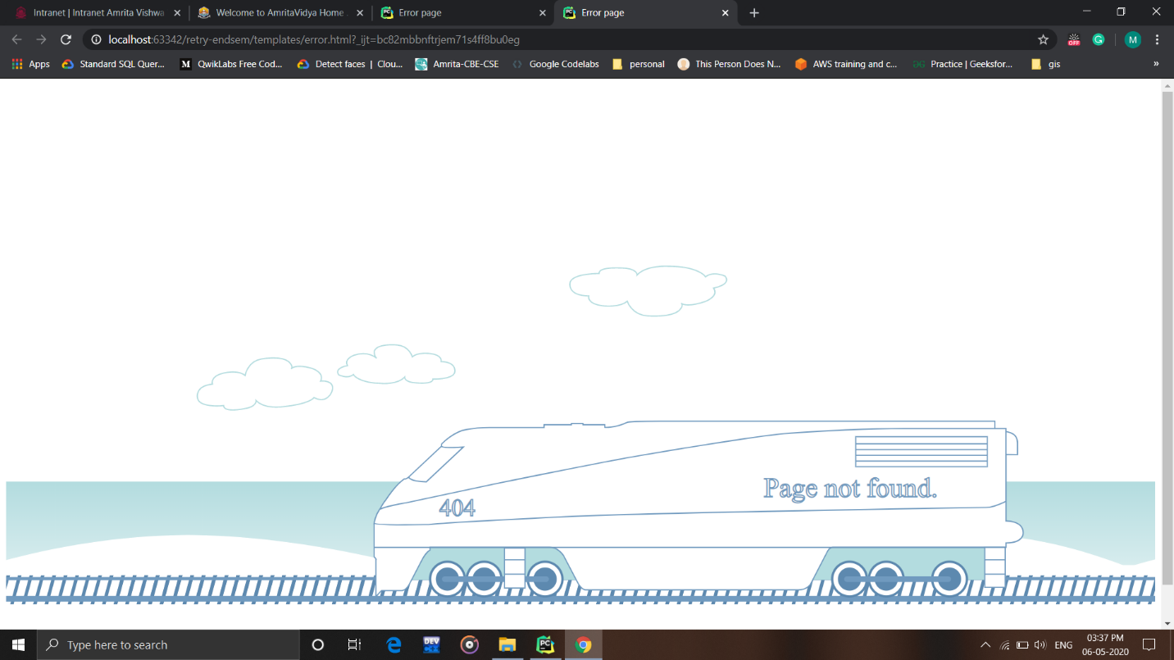

# REFERENCES

1. Stackoverflow ( a lot )
2. <https://spacy.io/> ( The core model)
3. <https://realpython.com/tutorials/flask/>
4. My previous openlab endsem attempt (<https://github.com/Mahe-git2hub/openlab-endsem.git> )
5. Many more …